**CREATE PROCEDURES**

**First do the** UTF setting

Windows-prefernece-general-workspace-Text file Encoding-other-utf-8

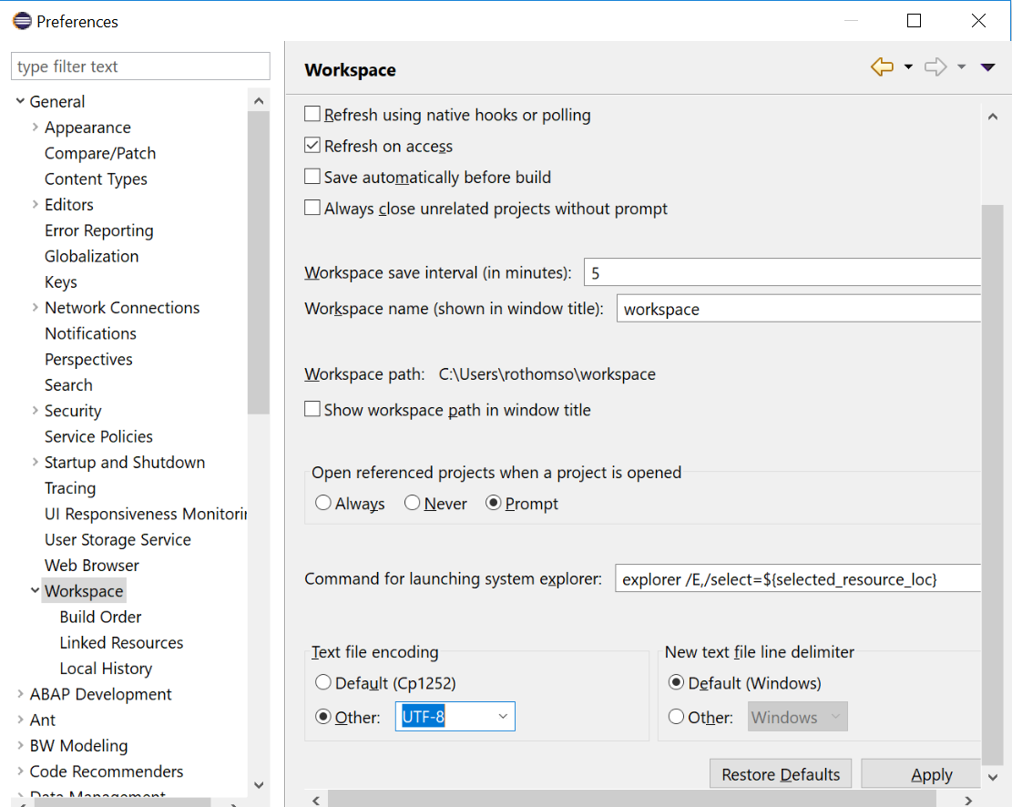

1. Open HANA Development perspective.

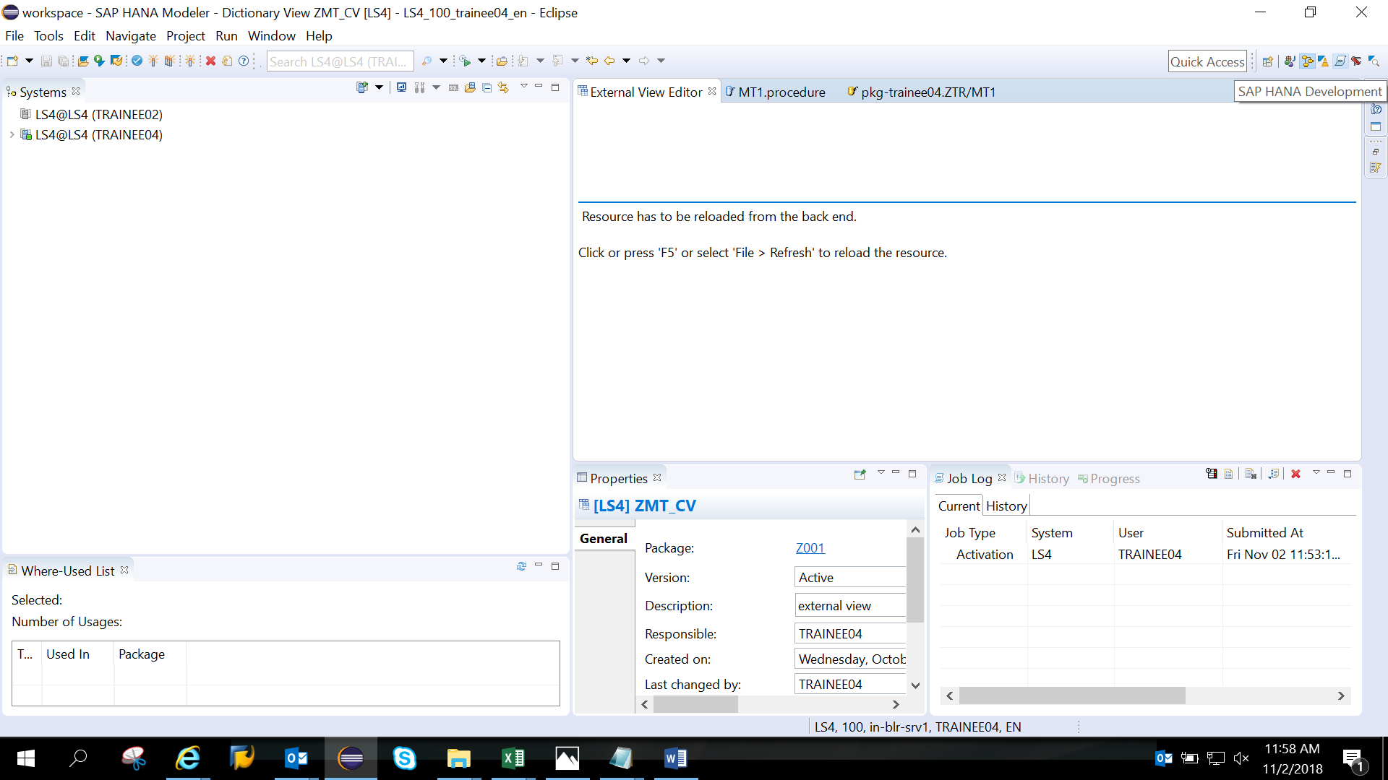

1. Below screen appears

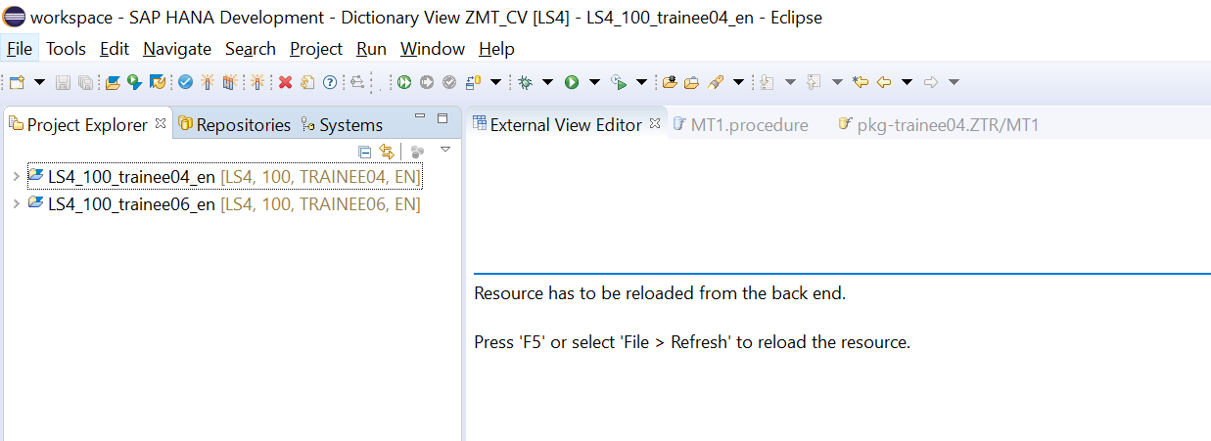

1. In repository tab click on create repository workspace.

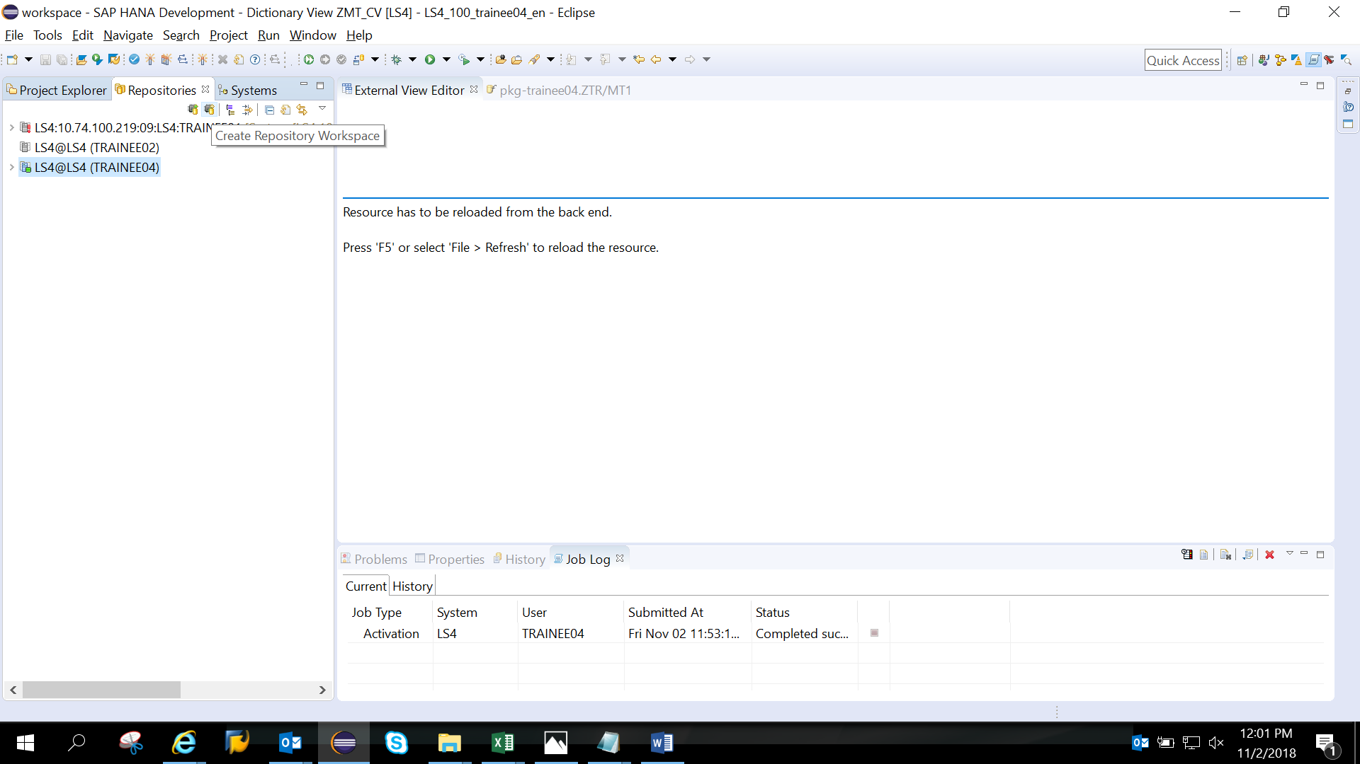

4) **Uncheck default and give details**

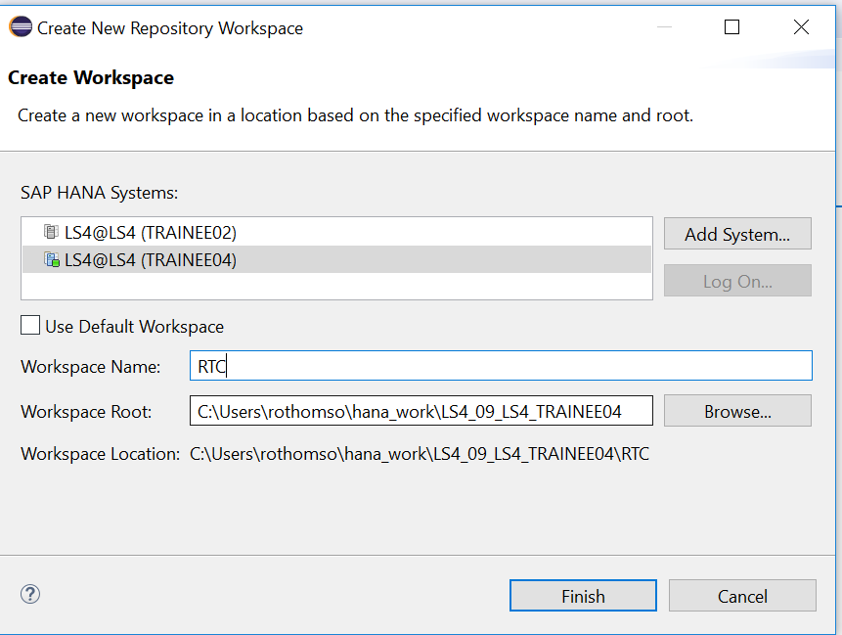

5) Right click on package as shown

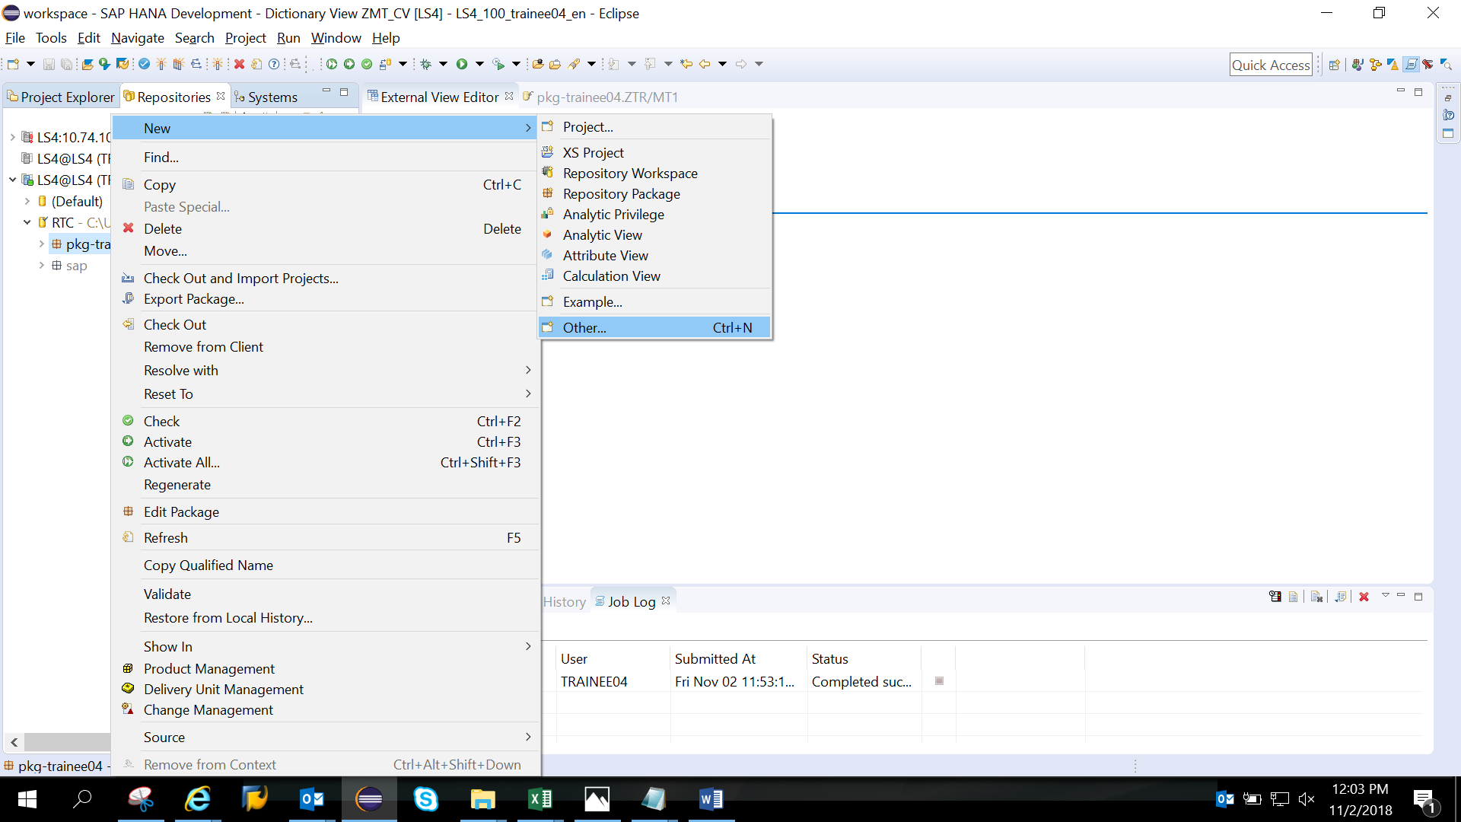

6)Search file

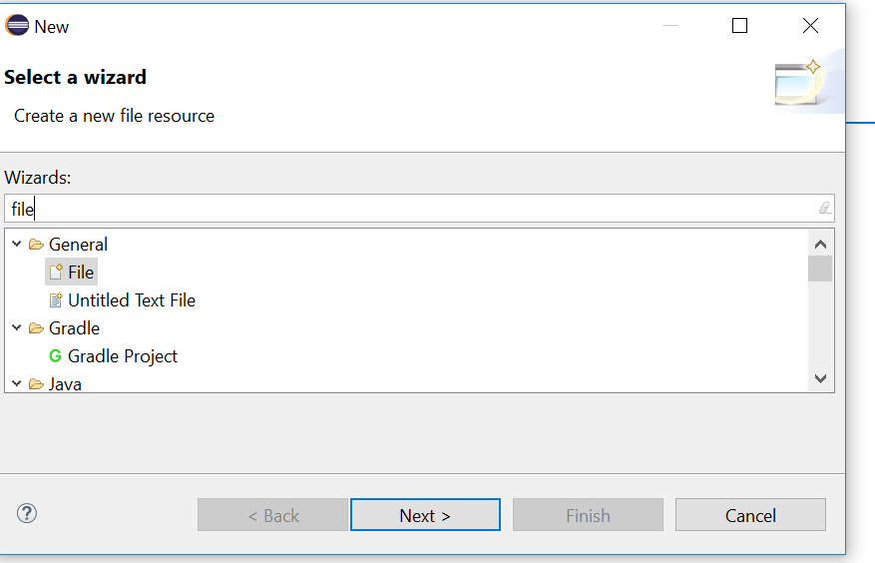

7)

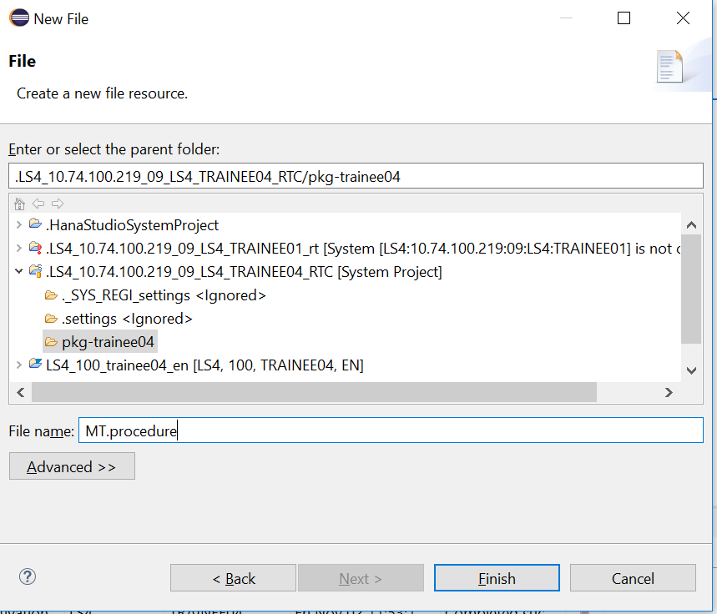

8)edit the template of procedure as shown

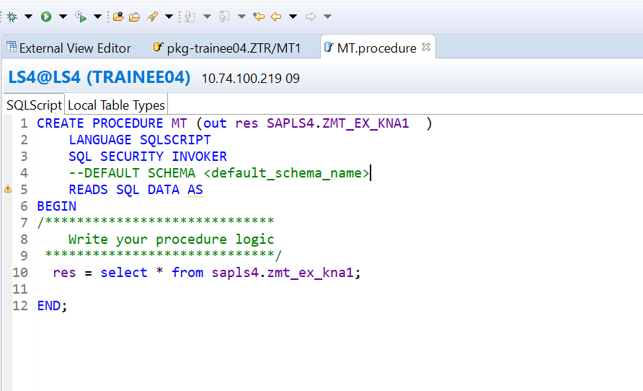

CREATE PROCEDURE MTC ( out res SAPLS4.ZMT_EX_KNA1 )

LANGUAGE SQLSCRIPT

SQL SECURITY INVOKER

--DEFAULT SCHEMA <default_schema_name>

READS SQL DATA AS

BEGIN

/*****************************

Write your procedure logic

*****************************/

res = select * from SAPLS4.ZMT_EX_KNA1;

END;

8)Right click on procedure - check -activate it

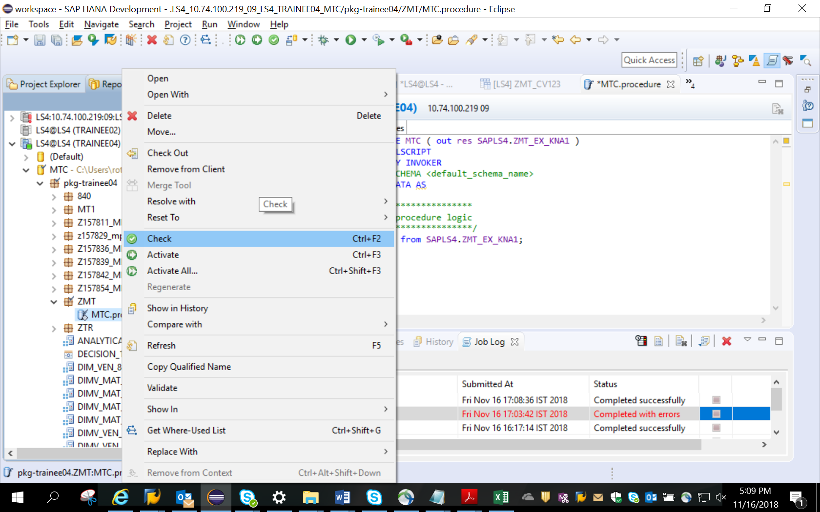

9)In modeler perspective- got to below path and search ur procedure

**Modeler perspective -SYS_BIC-Procedures-MTC.procedure**

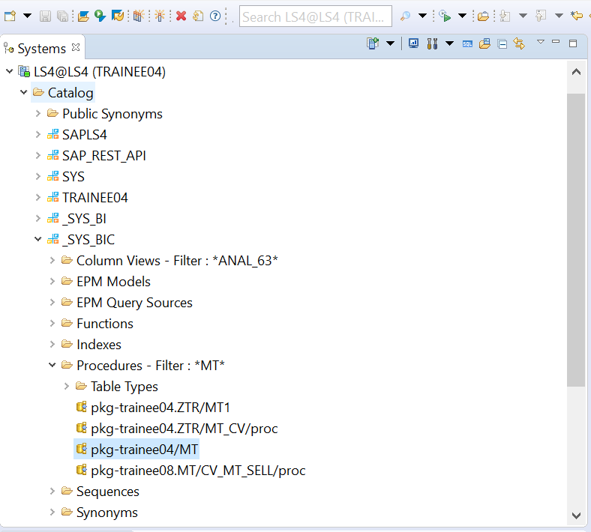

11) Open the SQL editor and drag and drop the procedure to the SQL editor

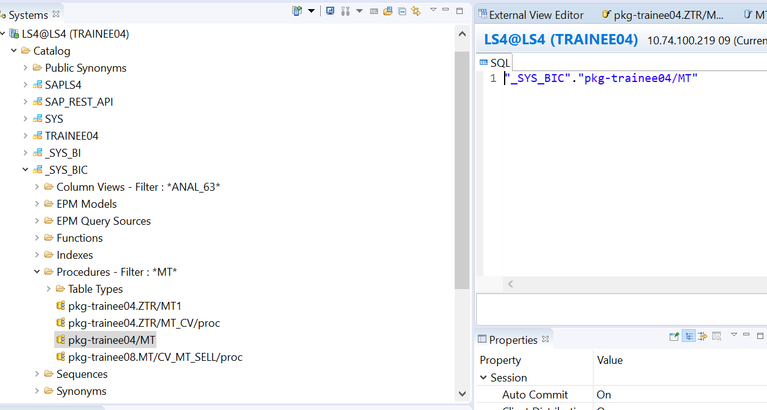

12) call the procedure by writing call statement.

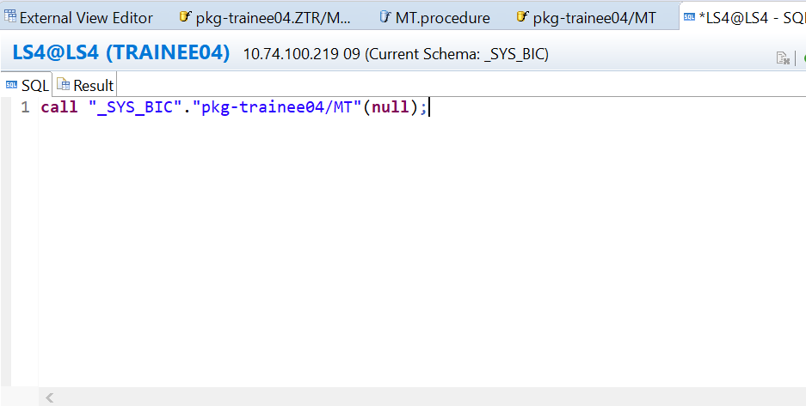

13) execute

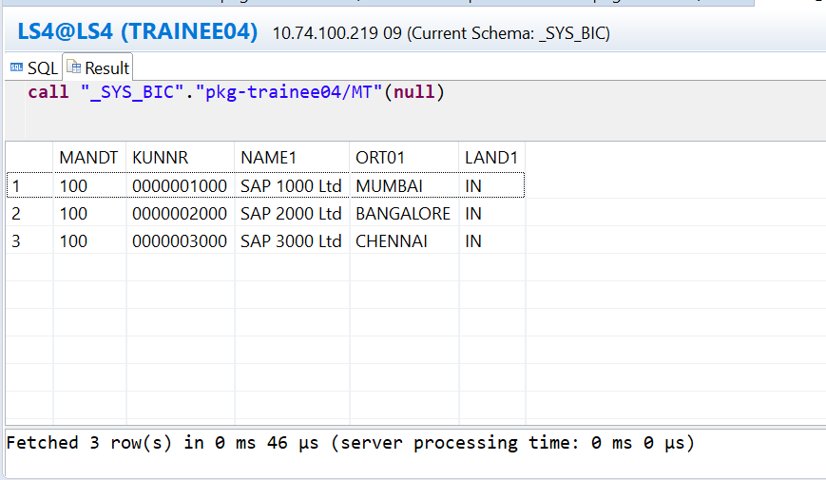

14) To consume this procedure from ABAP code, write ADBC program and replace v_Sql with below code

V_SQL = | CALL "_SYS_BIC"."pkg-trainee04/MT"(**null**);| .

***ADBC CODE***   
REPORT ZRT.  
  
data : wa_SALES type ZMT_EX_KNA1,  
       it_SALES type TABLE OF ZMT_EX_KNA1.  
  
 DATA: O_conn   type REF TO cl_sql_connection,  
       o_sql    type REF TO cl_sql_statement,  
       o_result type REF TO cl_sql_result_set,  
       V_SQL    TYPE STRING,  
       o_data   type REF TO data.  
  
*TRY.  
*Connect to the respective DB according connection  
CALL METHOD cl_sql_connection=>get_connection  
*  EXPORTING  
*    con_name = 'ADM_HDB'  
*    sharable = SPACE  
  RECEIVING  
    con_ref  = O_CONN  
    .  
* CATCH cx_sql_exception .  
*ENDTRY.  
  
CREATE OBJECT o_sql  
  EXPORTING  
    con_ref = O_CONN  
*    tab_name_for_trace =  
    .  
  
V_SQL =  | call "_SYS_BIC"."pkg-trainee04/MT"(null ) | .  
  
  
*TRY.  
CALL METHOD o_sql->execute_query  
  EXPORTING  
    statement   = V_SQL  
*    hold_cursor = SPACE  
  RECEIVING  
    result_set  = O_RESULT  
    .  
* CATCH cx_sql_exception .  
* CATCH cx_parameter_invalid .  
*ENDTRY.  
  
get REFERENCE OF it_SALES into o_data.  
*TRY.  
CALL METHOD o_result->set_param_table  
  EXPORTING  
    itab_ref             = o_data  
*    corresponding_fields =  
*    lob_fields           =  
    .  
* CATCH cx_parameter_invalid .  
*ENDTRY.  
  
data v_count type i.  
*Data Records into internal table  
*TRY.  
CALL METHOD o_result->next_package  
*  EXPORTING  
*    upto     = 0  
  RECEIVING  
    rows_ret = v_count  
    .  
* CATCH cx_sql_exception .  
* CATCH cx_parameter_invalid_type .  
*ENDTRY.  
  
cl_demo_output=>display( it_SALES ).